FoodTrack

Supplementary Specification

Version 1.0

Revision History
Date | Version | Description | Author
20/MAR/2019 | 1.0 | Initial Requirements Statement | Opriş Bogdan-Alexandru

Table of Contents
1. Introduction 4
2. Non-functional Requirements 4
2.1 Availability 4
2.2 Performance 4
2.3 Security 4
2.4 Testability 4
2.5 Usability 4
3. Design Constraints 4

Supplementary Specification

Introduction
The Supplementary Specification captures the system requirements that are not readily captured in the use cases of the use-case model. Such requirements include:
- Legal and regulatory requirements, including application standards.
- Quality attributes of the system to be built, including usability, reliability, performance, and supportability requirements.
- Other requirements such as operating systems and environments, compatibility requirements, and design constraints.

Non-functional Requirements

Availability
The system is not expected to be used in urgent scenarios so we can afford a SLA of 99.5%. This translates into a yearly downtime of roughly 1 day and 19 hours, or a monthly downtime of 3 hours and 39 minutes. This time can be used to perform software updates, data compression and garbage collection.

Performance
Performance is a thoroughly key factor for this system. In this case we can agree for an almost instantaneous response time for the updates made by the administrator in the database or by the users in their diary.

Security
The system will be secured using https encrypted connections. Also we will demand user authentication and will not keep passwords in plain text. Other user data will not be encrypted as we do not find it as being sensible information.

Testability
The system will be precisely tested with different stages of the design process respecting the flow shown below (Figure 1 . V-Model Testing): Unit Testing, Integration Testing, System Testing, Acceptance Testing.
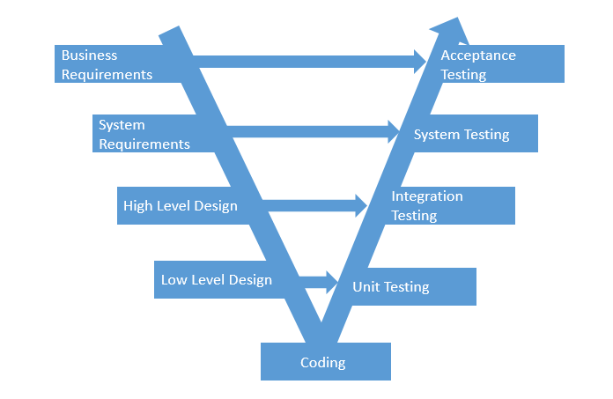
Figure 1 V-Model Testing

Usability
The user should be able to reach their desired goal very quickly. The interface provided by the application should be user-friendly both for the users and administrators.

Design Constraints
The system’s implementation language will be Java 8, which is suited to provide all the requirements in order to provide this system. The software development process will be the Rational Unified Process (RUP), tailored to fit the team and the project. The conceptual architecture of the system will be a client server as illustrated in Figure 2 Conceptual Architecture. The required development tools are either Eclipse IDE or IntelliJ IDEA. In terms of libraries we will use: JavaFX, Hibernate, JDBC and GSON.
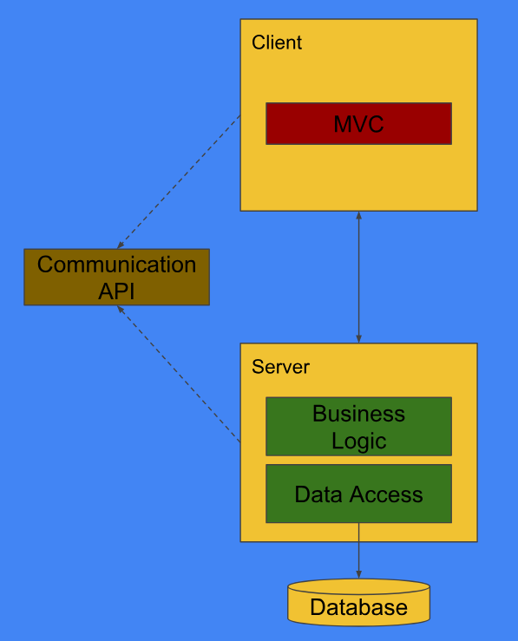
Figure 2 Conceptual Architecture

SLA = Service Level Agreement = Availability

